**Capstone Project Concept Note and Implementation Submission**

1. Project Overview

* **Title**: Predicting Future Temperatures Using Machine Learning
* **Team member**: TARIK SOLOMON TESHOME
* **Problem Statement**: Climate change is causing significant shifts in global and regional temperatures. Accurate temperature predictions are crucial for planning climate action and mitigating its impacts across various sectors.
* **SDGs Addressed**: Mainly SDG 13 (Climate Action), with impacts on SDG 11 (Sustainable Cities and Communities), SDG 2 (Zero Hunger), SDG 3 (Good Health and Well-being), and SDG 15 (Life on Land)​​.

2. Objectives

* Develop a machine learning model to predict future temperatures based on historical data.
* Contribute to the understanding of climate change impacts, aiding in adaptation and mitigation strategies.

3. Background

* **Importance of Research**: The urgency to predict and manage the effects of climate change, particularly temperature variations, is essential for policy-making and environmental management.
* **Existing Solutions**: Current methods include various machine learning and AI approaches, which have shown potential in climate science but often lack simplicity and interpretability​​.

4. Methodology

* **Machine Learning Techniques**: Use of Linear Regression, ARIMA, Decision Trees, Random Forests, and Support Vector Machines. These methods are chosen for their balance between predictive power and interpretability​​.
* **Data Handling**: Focus on preprocessing including cleaning, normalization, and temporal alignment of Earth Surface Temperature Data​​.

5. Architecture Design Diagram

* A schematic showing the data flow from the Earth Surface Temperature Data repository to the various machine learning models, including data preprocessing steps.

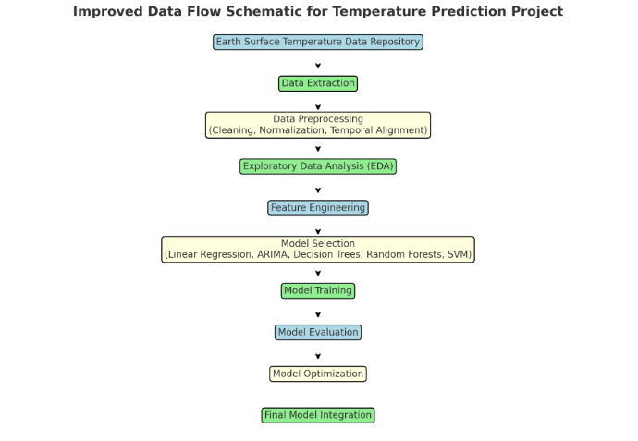

6. Data Sources

* **Primary Source**: Earth Surface Temperature Data, encompassing global geographic locations over a long-time span in a structured CSV format​​.
* **Data Exploration**: Analysis to reveal trends like rising average temperatures, seasonal variations, and geographical differences​​.

7. Literature Review

One significant study, "Predicting Global Patterns of Long-term Climate Change from Short-term Simulations Using Machine Learning," published in npj Climate and Atmospheric Science, employed machine learning to convert short-term climate data into long-term forecasts. This study notably used Ridge regression and Gaussian Process Regression (GPR), focusing on training the models on climate simulations. The contribution of this research lies in its demonstration of the potential of statistical models in climate science, particularly in reducing computational costs.

Another important study, titled "Forecasting Climatic Trends Using Neural Networks: An Experimental Study Using Global Historical Data" from Frontiers, utilized neural networks, specifically the LeNet architecture, to predict climate trends. This research stands out for its method of employing graphical images of temperature data for Deep Neural Network (DNN) training. Its significant contribution is the introduction of an AI-based approach to climate forecasting, showcasing the versatility of neural networks in analyzing complex climate data.

Furthermore, the study "Developing Machine Learning Algorithms for Meteorological Temperature and Humidity Forecasting at Terengganu State in Malaysia," featured in Scientific Reports, evaluated various machine learning algorithms for predicting temperature and humidity. The methodology involved using 24 years of data from the Malaysia Meteorological Department, and the study's primary contribution was demonstrating the effectiveness of machine learning algorithms in regional meteorological predictions.

Lastly, "Training Machine Learning Models on Climate Model Output Yields Skillful Interpretable Seasonal Precipitation Forecasts," published in Communications Earth & Environment, investigated the application of machine learning models on ensembles of climate model simulations for seasonal forecasting. This research applied these models to numerous seasons of simulations, illustrating the potential of machine learning to produce accurate and interpretable seasonal forecasts.

These studies collectively highlight the growing importance and effectiveness of machine learning in climate science, from global temperature trends to regional meteorological forecasts, offering innovative approaches and methodologies for tackling one of the most pressing issues of our time.

**Implementation Plan**

1. Technology Stack

* **Programming Languages**: Python (primary), R (for statistical analysis).
* **Libraries**:
  + Python: NumPy, pandas (for data manipulation), scikit-learn (for machine learning algorithms), TensorFlow and Keras (for deep learning), Matplotlib and Seaborn (for visualization).
  + R: ggplot2 (for advanced statistical visualizations).
* **Frameworks**: Jupyter Notebook (for interactive coding and data analysis), TensorFlow (for deep learning models).
* **Software/Hardware Components**:
  + Software: Git for version control, Kaggle and Google Colab for cloud-based model training and experimentation.
  + Hardware: High-performance computing resources for intensive model training.

2. Timeline and Task Distribution

* **Data Collection and Preprocessing** (Week 1-2):
  + Collection of Earth Surface Temperature Data.
  + Data cleaning, normalization, and temporal alignment.
  + Exploratory Data Analysis for initial insights.
* **Model Development** (Week 3):
  + Selection and initial setup of machine learning models.
  + Feature engineering and model architecture design.
* **Training and Evaluation** (Week 3-4):
  + Model training with various algorithms.
  + Performance evaluation using metrics like accuracy, MSE, etc.
* **Deployment** (End of Week 4):
  + Final model selection based on evaluation.
  + Deployment of the model for predictions.

Task Distribution Matrix:

* Team Member 1: Focus on data collection and preprocessing, and model evaluation.
* Team Member 1: Specialize in model development, training, and deployment.

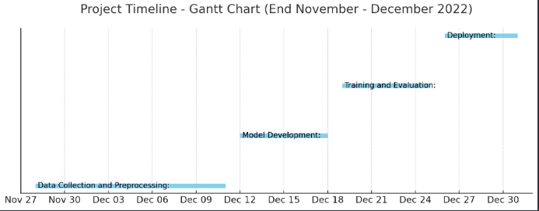

3. Milestones

* **End of Week 1**: Completion of data collection and initial preprocessing.
* **End of Week 2**: Completion of in-depth EDA and feature engineering.
* **End of Week 3**: Development and initial training of models.
* **End of Week 4**: Final model evaluation and deployment.

4. Challenges and Mitigations

* **Data Quality**: Ensuring the accuracy and relevance of temperature data.
  + Mitigation: Rigorous data cleaning and validation processes.
* **Model Performance**: Achieving high accuracy and reliability in predictions.
  + Mitigation: Experimentation with various algorithms and tuning models.
* **Technical Constraints**: Limitations in computational resources.
  + Mitigation: Utilizing cloud platforms for resource-intensive tasks.

5. Ethical Considerations

* **Data Privacy**: Ensuring the ethical use of temperature data, respecting any privacy concerns.
* **Bias**: Avoiding biases in data and models that could skew predictions.
* **Community Impact**: Considering the potential impact of predictions on target communities and ensuring responsible communication of findings.